1. A) There are 3 main phases in database design.

* Conceptual design: This model is used to define the data elements and relationship for a specified system. It also develops a very simple and easy to design view of data. In ER modeling, the database structure is portrayed as a diagram called an entity-relationship diagram. Conceptual ERD is the simplest model among all.
* Logical design: The process of logical design involves **arranging data into a series of logical relationships called entities and attributes**. An entity represents a chunk of information. In relational databases, an entity often maps to a table.
* Physical design: Database designers produce physical data models by elaborating on the models created in the conceptual and logical data modeling stages. During physical design, you transform the entities into tables, the instances into rows, and the attributes into columns.

B) Entity relationship (ER) data model is a conceptual model that represents the information structure of a problem domain in terms of entities and relationships.

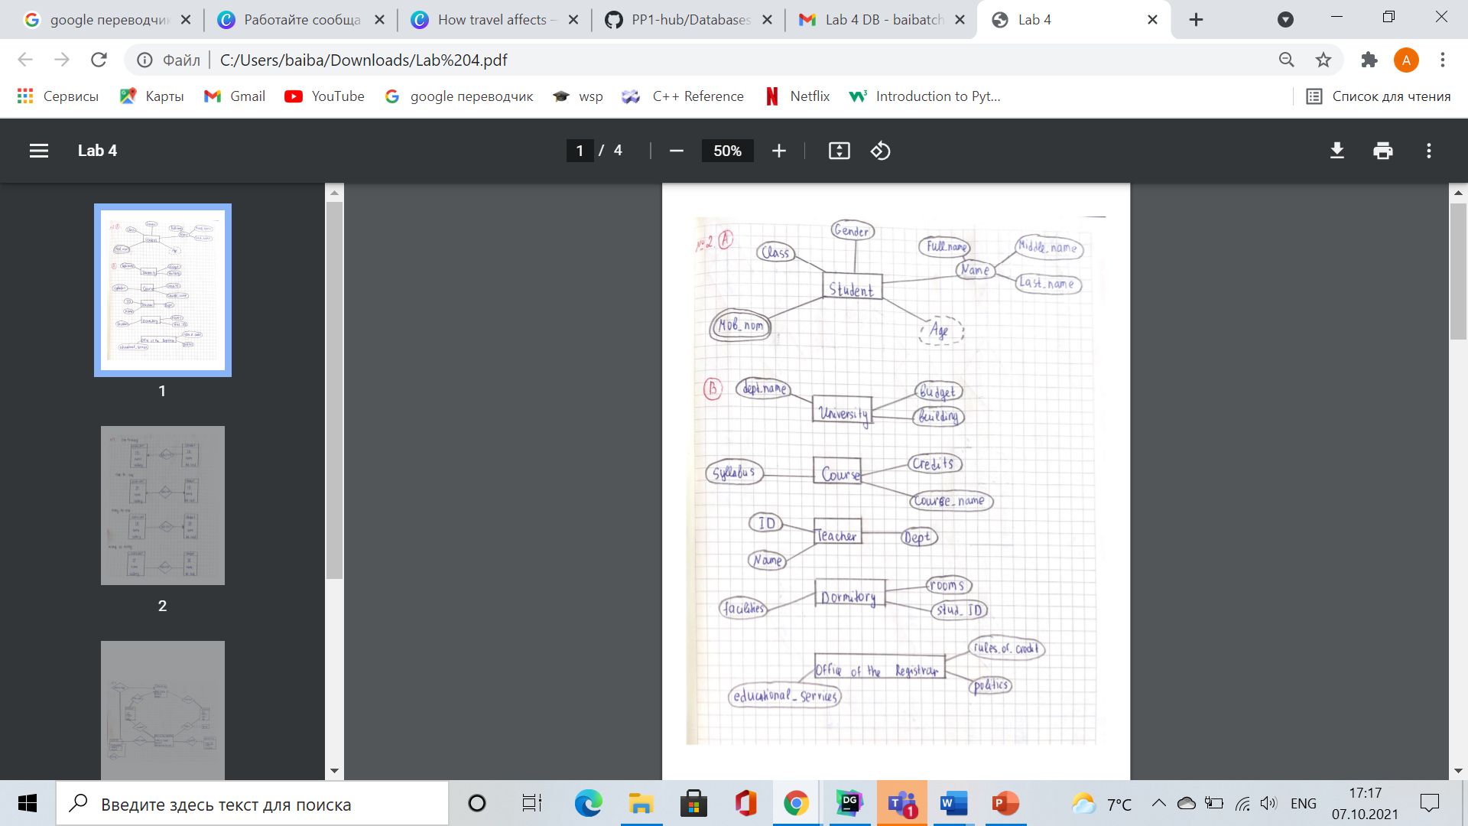

1. 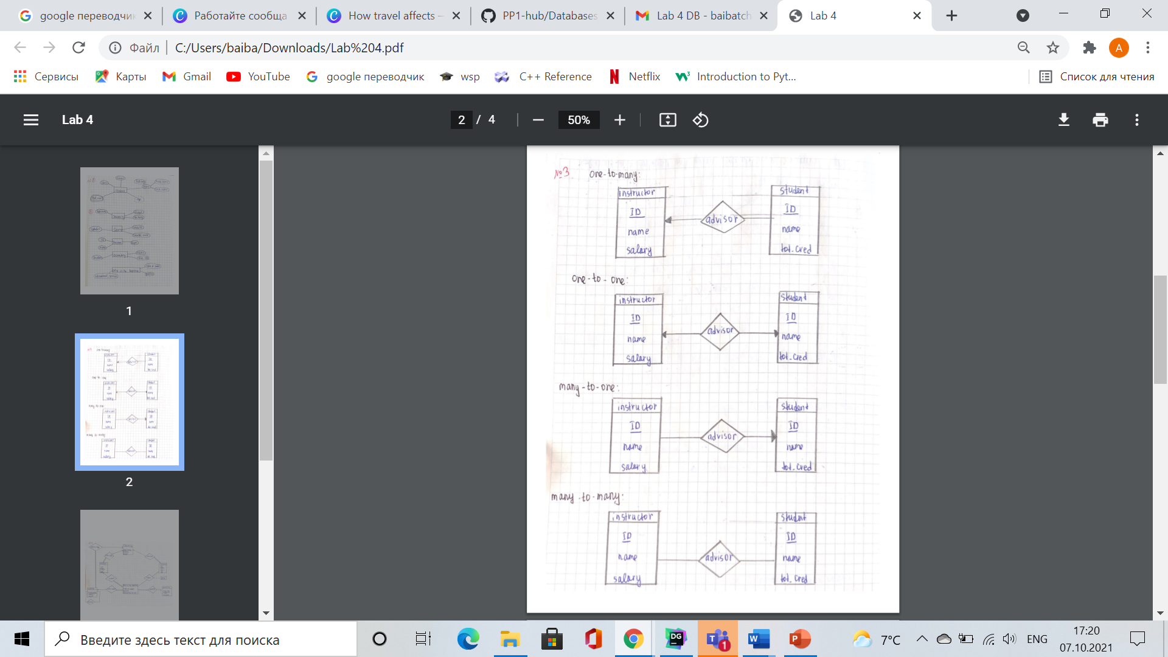

4.

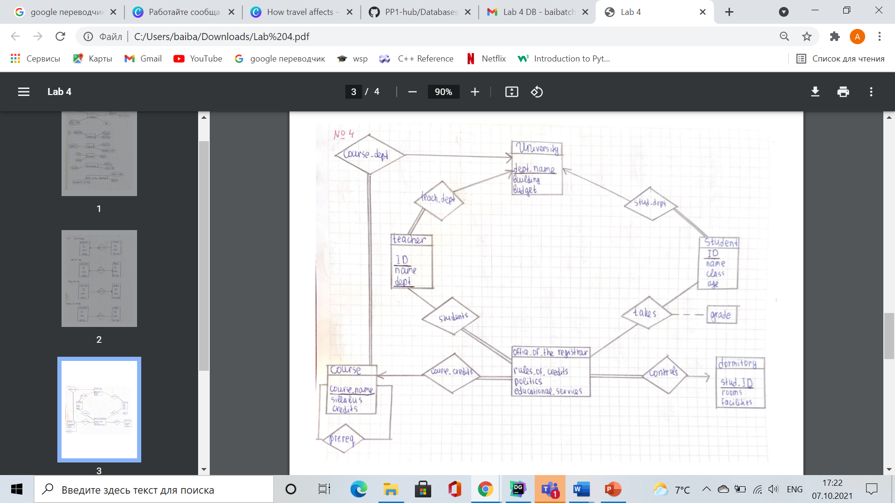

5.

